2D Presentation Techniques

- What is the definition of pictorial elements?
Relating to, consisting of, or expressed by pictures
- What are the four basic 2D shapes?
Circle, rectangle, square, triangle
- What is HUE? a color or shade.

- What should be considered when choosing a theme for a presentation? The audience and the goal of the presentation.
- What is the Focus of a presentation?
The attention given to any in particular element that stands out or/is associated with the main idea.

- What are the two types of balance? Formal or informal

- What is Weight in a presentation? How heavy the element used in the presentation appears with respect to the design characteristics.

- What does Placement in visualization refer to? the overlapping, closeness, or division that forms the proximity of the elements in the presentation.

- What does Setting refer to in a presentation? To show something natural or artificial in an environment.

- For each of the following, write a definition and then look at the examples of each.

Picture Window- Most popular format styles that are used when images dominate the largest proportion of the layout

Type Specimen- It is used when an enlarged typeface when the element in the layout is important.

Copy Heavy- Is used when the information or copy is the most important element in the layout.

Mondrian- Layouts that are produced by dividing the space into rectangles of different scale and proportion. All of the text, headings, and images are placed in the rectangles.

Omnibus (Circus Layout) - Used when a variety of elements are needed in the layout.

Multipanel - Format that uses panels of equal size and many times are used to tell a sequential story.

Silhouette- The text wrapped around an open image, which usually does not have a background.

- For each of the following tools describe the function then copy and paste a picture of the icon.

Select- To highlight something specifically you want to do something withor to choose something.
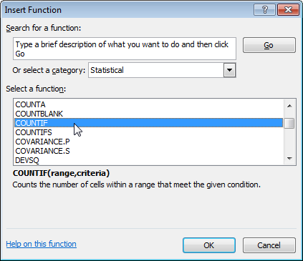

Knife- is used to cut something there are many types of knifes.
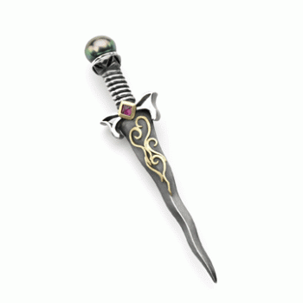

Magnify- Is to make something bigger
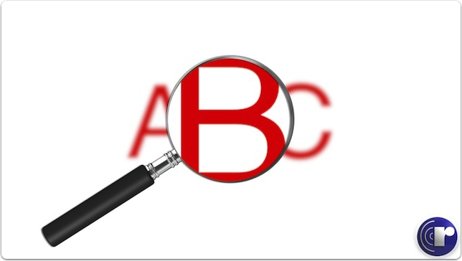

Text- converts a numeric value to text and lets you specify the display formatting by using special format strings. This function is useful in situations where you want to display numbers in a more readable format, or you want to combine numbers with text or symbols.
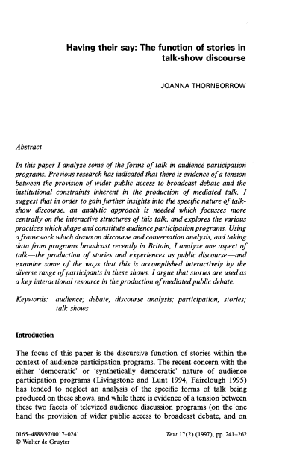

Fill - To input something somewhere or in it or complete it.
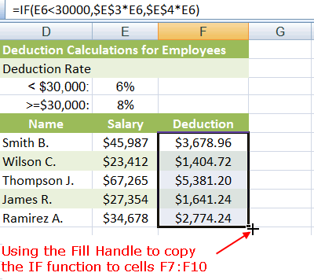

Pan- Is a type of utensil that is used to cook/fry food.
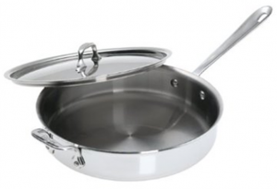

Eyedropper- draws liquid in and releases one drop at a time.
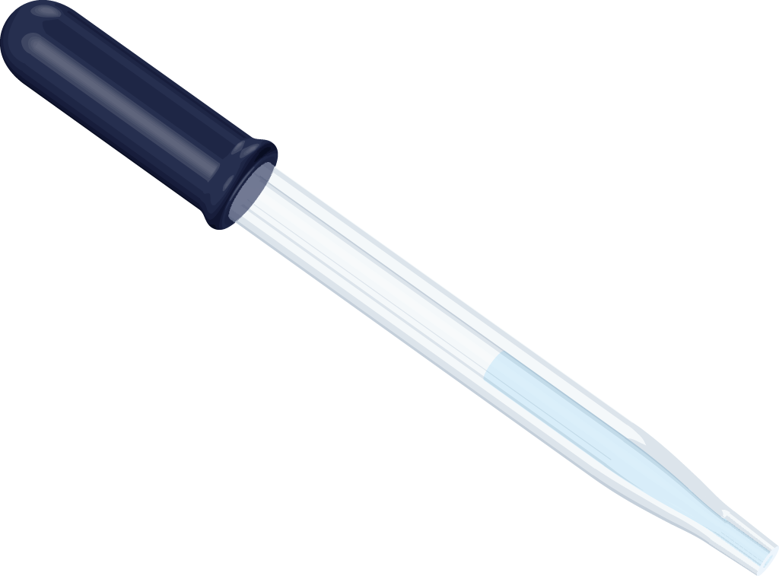
Gradient - Changes the intensity or color in an image. Image gradients may be used to extract information from images.
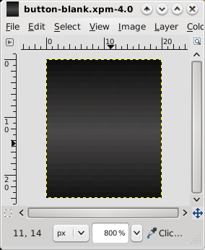

Blend- To mix or combine two or more different things.
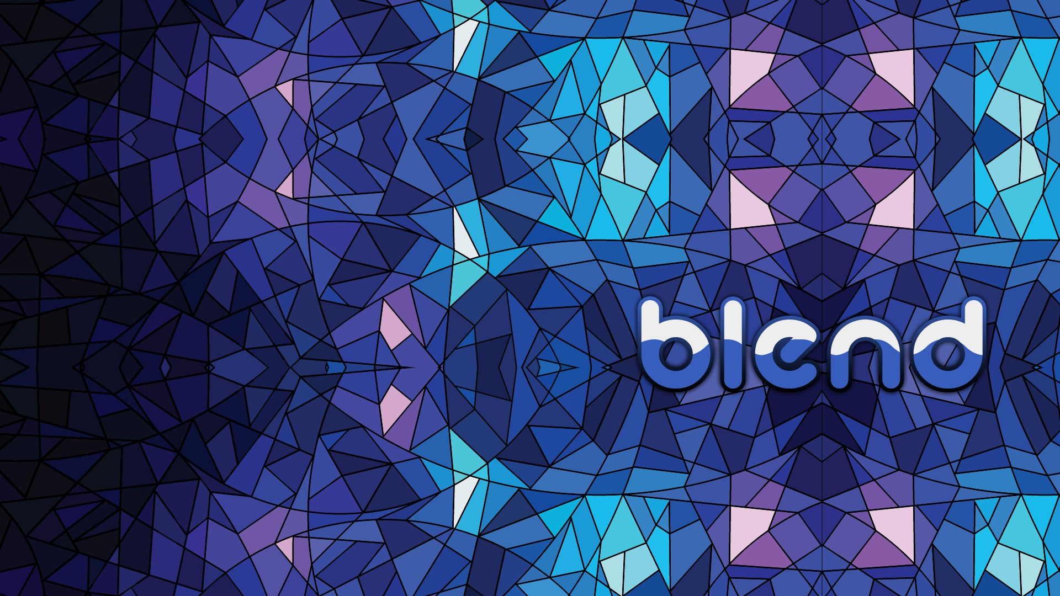

Crop- To cut off something not important to you from something or to take off ; removing.

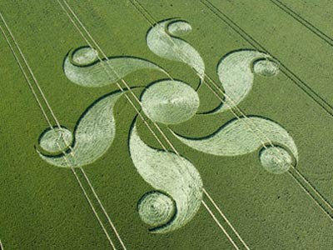

- What should you consider when using background on your slides?
White
- What is the 6, 6, 6 rule?
No, more than 6 words, 6lines.6inches per page.
- How many images should be used on any given page?
However many you want
- What is White Space?
Blank space
- What is the SAFE Design Concept?
IDK
- What are the three Principles of Design?

Number 1
Number 2
And number 3
- What are examples of Elements of Design?
Drawings, photographs or continuous tone images.
- What should you remember when using text for slides?
Various formats

