UNIT D: Underlying Principles of Visualization

OBJECTIVE: V104.01
Describe design fundamentals.

Aspects of design
1. Problem solving is the understanding of what is needed to solve a problem, which includes design, making choices and revisions.
2. Visual Communication is the art of seeing by using pictures and words to convey information about different ideas and concepts.
3. Function and information refer to the purpose and value of design as well as the message conveyed with respect to a selected audience.

Principles of design
- Balance is the optical illusion of the equal spacing of objects.
a. Formal balance is symmetrical. When elements on a page can be centered and/or evenly divided both horizontally and vertically, it has symmetry. Symmetrical balance is generally for more formal, orderly layouts. These layouts often convey a sense of tranquility, familiarity, elegance, or serious thought.
b. Informal balance is asymmetrical. It involves placement of elements in a manner that allows elements of varying visual weight to balance one another around an imaginary point. For example, it is possible to balance a heavy weight with a cluster of lighter weights on equal sides of the imaginary line.

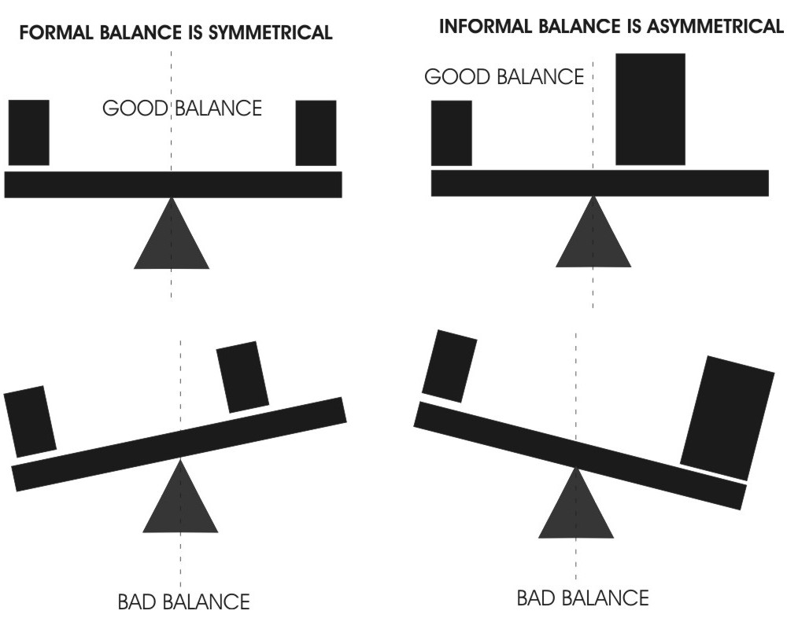

- Rhythm is a recurring movement or pattern, which can produce a feeling of motion in the design. Size, shape, color, spacing, angles, and texture of the materials are all factors in placing rhythm in a design and can help lead the eye in some direction. Different types of rhythm will produce different effects in the design.
a. Repetition (repeating similar elements in a consistent manner).
b. Variation (change in form, size or location).

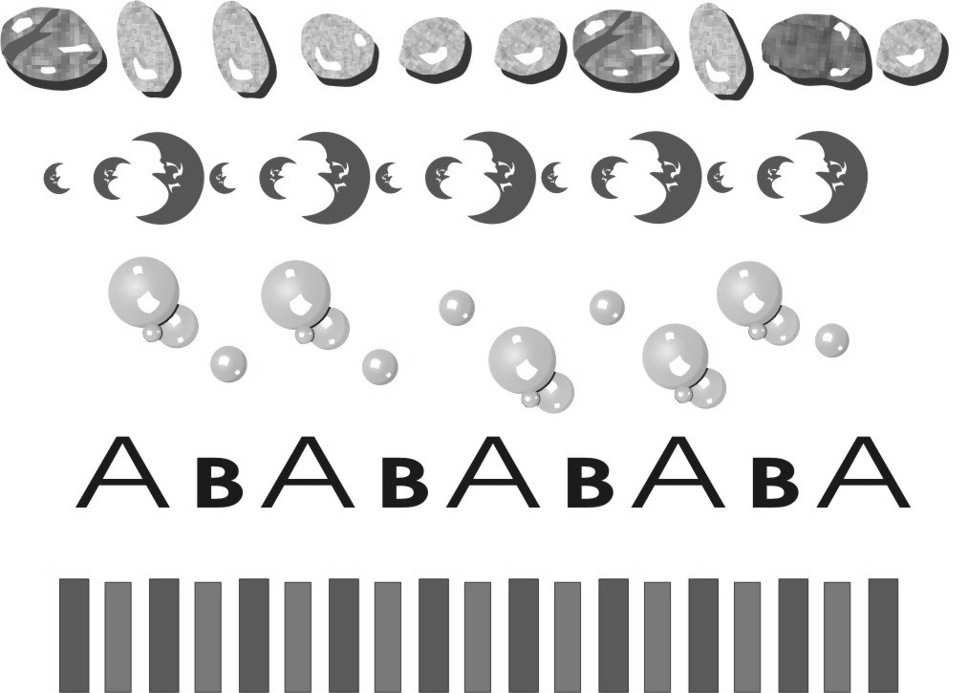

3. Proportion- relative size of one object in comparison to another. The human body is a considered an ideal proportion based on the size relationships between the body and the head. A caricature is funny because the head is out of proportion.
C. Methods of design
1. Emphasis is the method use to draw attention to a part of the design by making it the focal point or the main idea. There are common techniques that are used to add emphasis in a design:
- Use contrasting elements (big, small, thick, thin, negative, and positive).
- Use color for the most important element.
- Reverse an element out of the background.

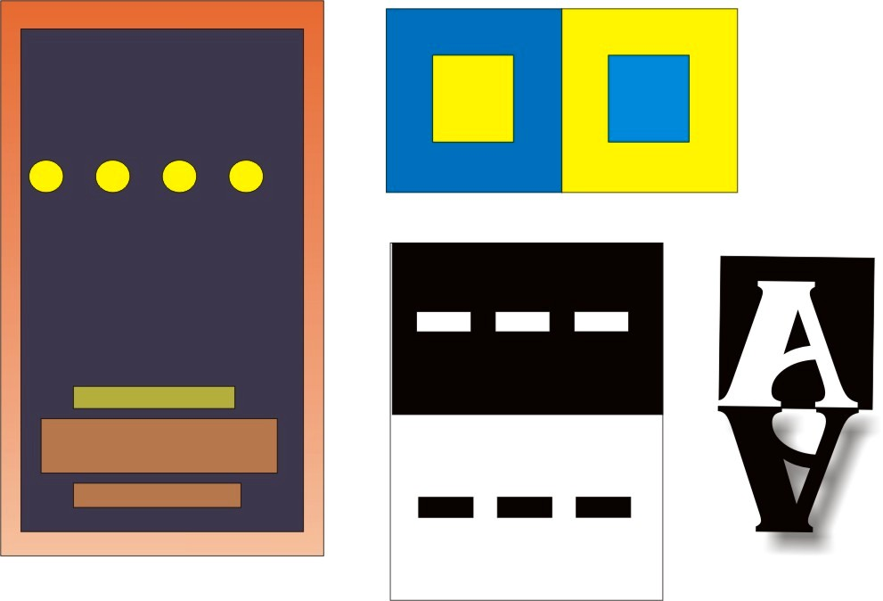

2. Unity is the completeness and harmony of a design. Unity is achieved when all the elements belong together. Several methods of organization are used to produce unity in the design:
a. Grouping
b. Using a grid (subdivision of space)
c. Repetition–means repeating certain elements throughout the entire design. Using repetition can pull the design together (using a theme of squares then using different sizes and shapes of squares and rectangles). Example: using a repeated background on a PowerPoint presentation.
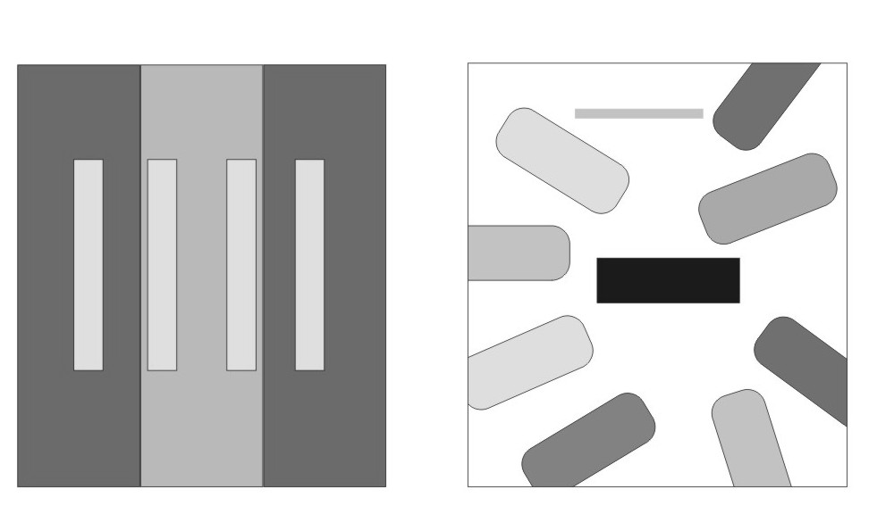
A Guideline: If an element can be removed
without affecting the design, it isn’t needed anyway.

D. Elements of design
1. Line has length, position and direction and is either visible or invisible. A line (curve) is basically any distance between two points. Lines can take on a variety of shapes and functions:
a. Connectors and separators
b. Outlines
c. Graphs and grids
- Symbolism

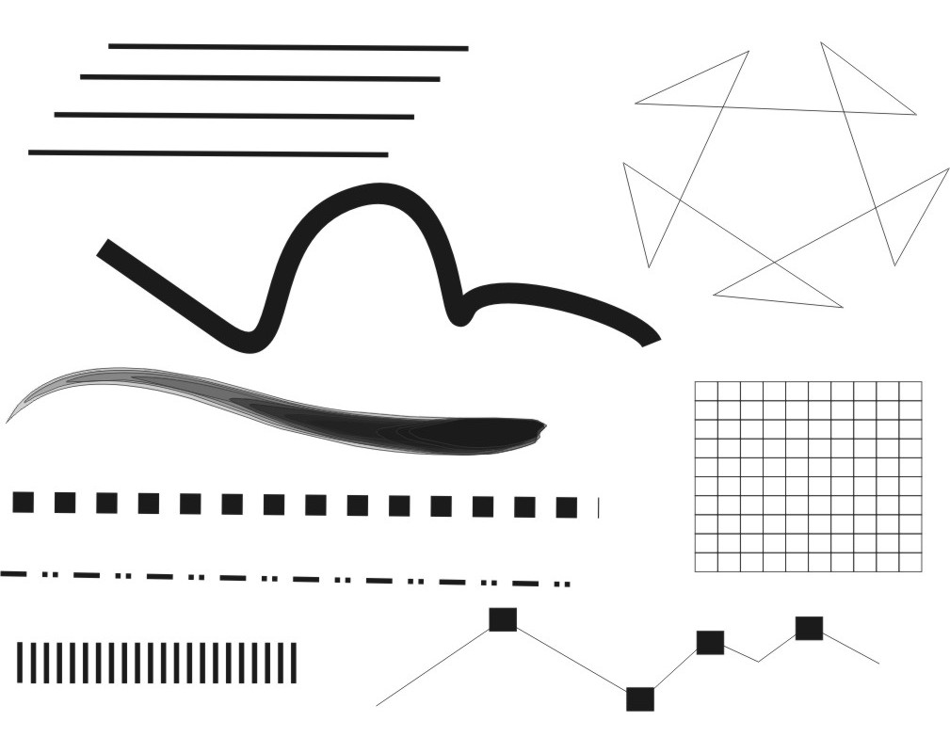

2. Shape is any form that occupies and defines negative and positive space (the area where the object is located is positive space and the area around the object is negative space). Shape is anything that has width, shape or depth. There are three types of shapes:
a. Geometric (triangles, squares, circles)
b. Natural (animals, plants, human)
c. Abstract simplified versions of natural shapes)

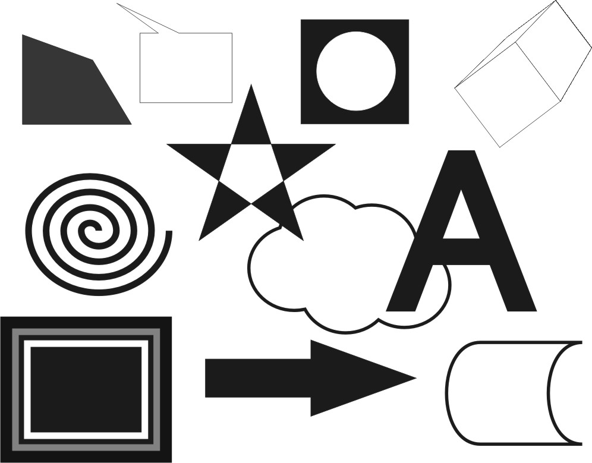

- Color is the hue of pigment or light and is produced by the subtraction or addition of primary and secondary colors produced from light.
a. Humans are restricted by the limitations of their eyes and ears to perceive the world.
b. Our eyes have cells, contained on the retina that chemically respond to different wavelengths of visible light, namely red, green, and blue. These colors are often referred to as the visible spectrum.
c. The visible light is only one small part of the electromagnetic spectrum. Other waves of the electromagnetic spectrum are always there, but our eyes cannot detect them.
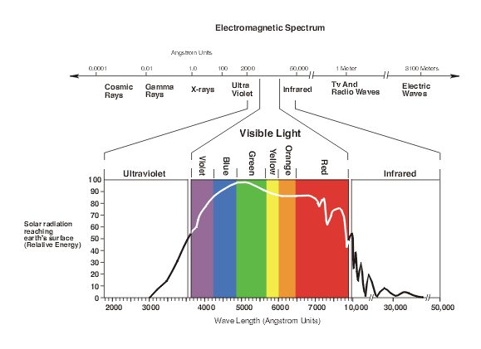
d. Color is the primary tool for symbolism in communication. There are different uses of color:
1. Attract the eye
2. Produce visual stimuli
3. Organization.
4. Provoke emotional response
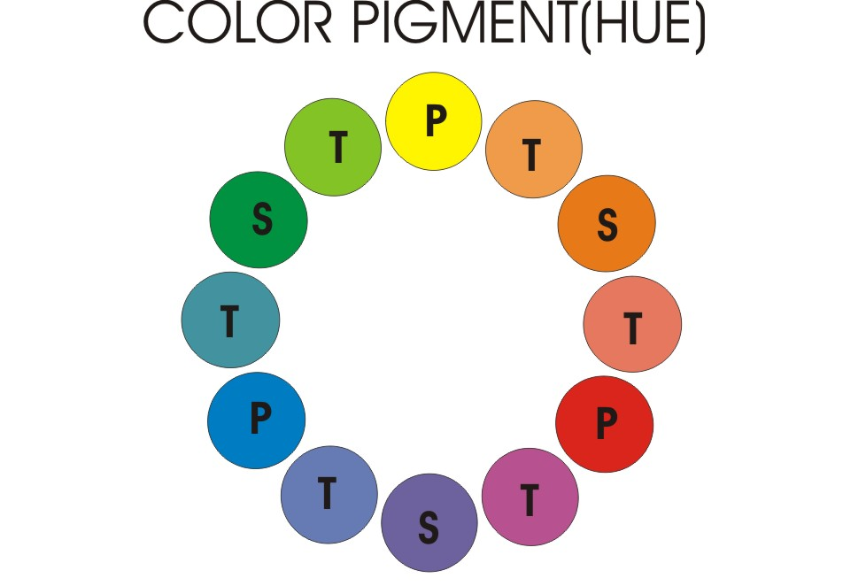
When primary colors are mixed with secondary colors,
they form intermediate or tertiary colors.
4. Texture is the look or feel or any object or surface. The appearance is either visual (illusionary) or tactile (physical to touch). Patterns are good examples of visual texture.

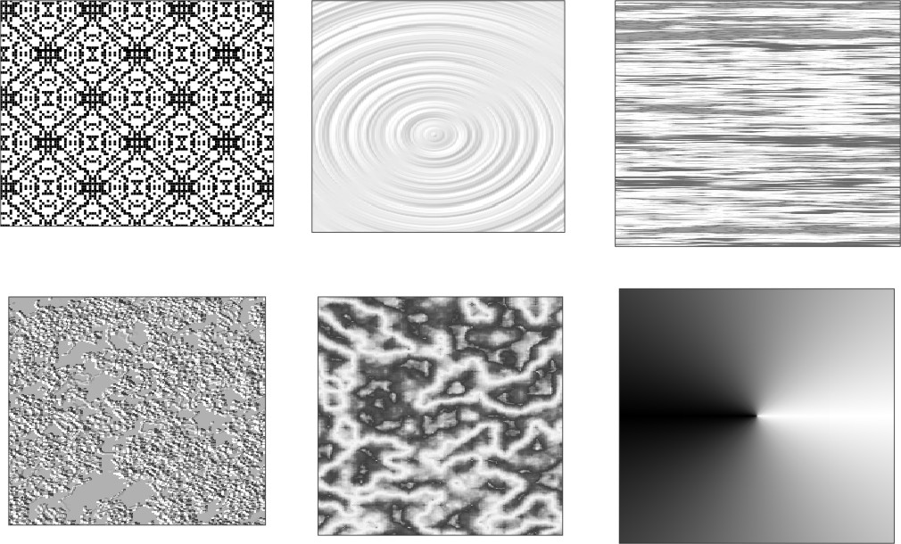

5. Space is the negative or positive area that an object or objects occupy in a design. Using simple principles can control the relative position of every element:
a. White Space - The space around you design and between elements in your design.
b. Overlapping elements
c. Value is the lightness or darkness of an object.

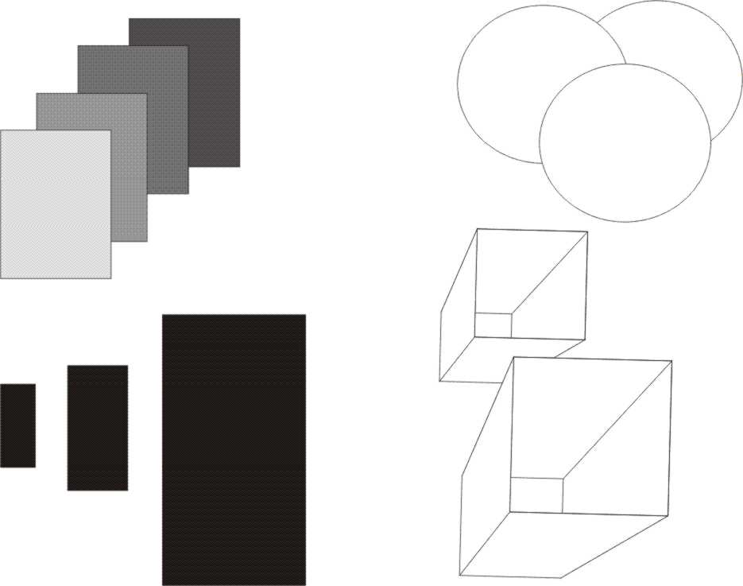

6. Size is how big or small objects are in relation to the space they occupy. The primary roles size plays in design:
a. Function (the age of the audience – older people would need type set larger to aid in reading)
b. Attractiveness (add interest by cropping or scaling the elements)
c. Organization (make the important element the largest and the least important the smallest)

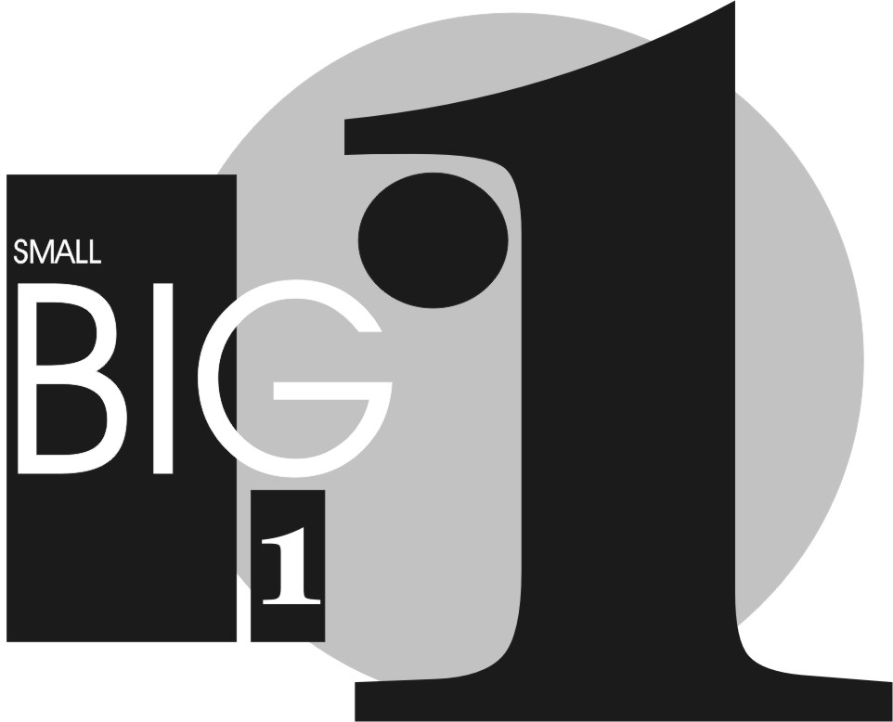

UNIT D: Underlying Principles of Visualization

OBJECTIVE: V104.02
Interpret color and its applications.

Introduction: The purpose of this unit is to introduce students to the basic components of color use and application.

A. Relationships between Additive and Subtractive color
1. Light Waves produce a range of visible energy that forms all the colors the human eye can see by adding/mixing the three primary colors of light; red, green and blue (RGB). These are called light colors. Mixing all the primaries in different proportions produce different visible colors of light.
- Equal mixtures of primaries form secondary colors.
- Equal mixtures of all primaries form white light.
- Unequal mixtures of different proportions of primaries make all other
colors
Red
Green
Blue

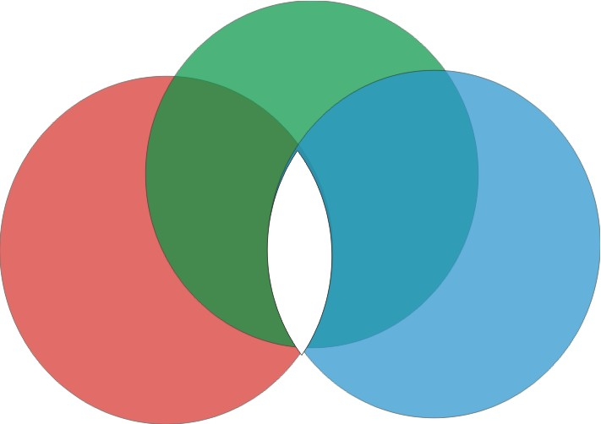

- Television and monitors create color using the primary colors of light. Each pixel on a monitor screen starts out as black. When the red, green, and blue phosphors of a pixel are illuminated, the pixel becomes white. This phenomenon is called additive color.
- Monitors, projection devices, TV, video, and movies all use the light model.
- Color from the light model is brighter and has a wider spectrum (gamma range) than that of CMYK (cyan, magenta, yellow, black).
2. Pigments are produced when certain wavelengths of light are absorbed and others are reflected or transmitted. This is how different colors, inks, dyes, and paints are made. This subtractive color system starts with an object that reflects light and uses dyes to subtract portions of the light to produce other colors. If an object reflects all the white light back to the viewer, it appears white. If an object absorbs (subtracts) all the light illuminating it, no light is reflected back to the viewer, and it appears black. It is the subtractive process that allows everyday objects around us to show color.

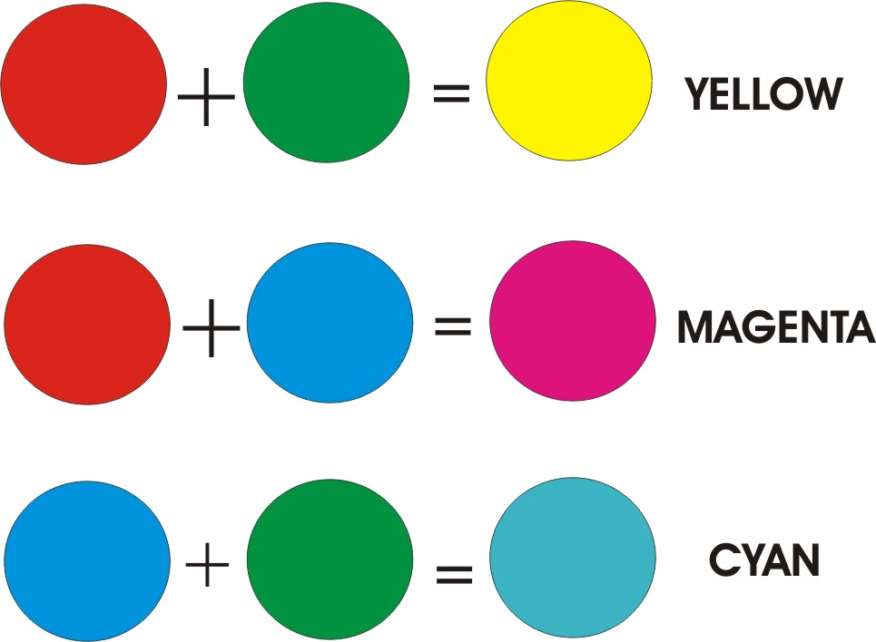

- The subtractive primary colors (magenta, cyan and yellow) subtract their complimentary additive primary colors.
- Color printing devices use the subtractive primaries to reproduce color.
- Color inks use the CMYK model. K stands for black and is used to mix with the other inks to form colors. This is necessary due to the impurities of ink.
- Secondary pigment colors are red, green, and blue, which correspond to the light primaries.
- Because the color spectrum is much larger for RGB, when files are converted from RGB to CMYK, colors in the RGB spectrum that are outside of the CMYK spectrum look dirty and muted Once converted, there is no way to recapture these colors. Unless you are making slides, videos, films, or Internet graphics, always start with a CMYK image file.

Cyan
yellow
magenta

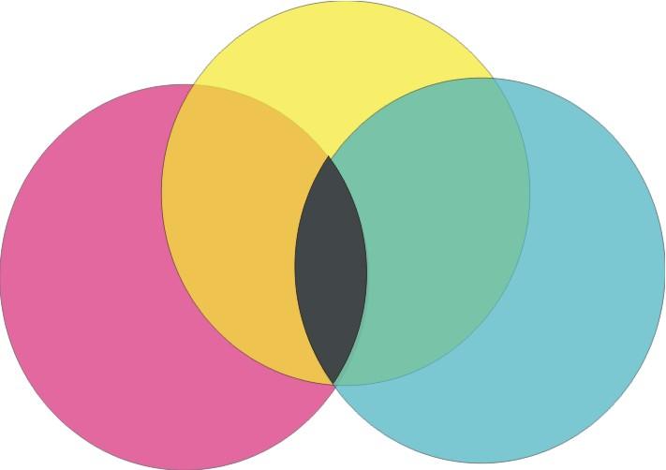

Colors absorbed (primaries) | Colors unaffected (reflected) | Subtractive Colors produced
Blue | Red and green | Yellow
Green | Red and blue | Magenta
Red | Blue and green | Cyan

- Reflected color refers to color images or photographs. Colors reflect off of the surface of the image.
- Transmissive color refers to color slides and transparencies. Color passes through the surface of the image because it is transparent.
- Transparent colors in printing are referred to as process colors (CMYK).
- In printing, opaque colors (reflected) are called pantone colors or Pantone Matching System (PMS) colors. This is the most popular spot color system in the graphics industry.

Color Model | Primary | Secondary | Primaries are mixed | Uses | Problems
RGB |  |  |  |  | Colors do not convert to CMYK correctly
CMYK |  |  |  |  | Muted colors  Less colors than RGB

B. Color used in communication
- Mood refers to meaning of colors that are responses to visual stimuli, which are attributed to feelings, attitudes, and values. Examples:
a. Black- authority and power popular in fashion because it makes people appear thinner, implies submission, overpowering, makes the wearer seem aloof or evil, and villains often wear black.
b. White- innocence and purity summer color, and doctors and nurses wear white to imply sterility.
c. Red- most emotionally intense color, stimulates a faster heartbeat and breathing, color of love, red clothes makes the wearer appear heavier, red cars are popular with thieves, and an accent color in decorating.
d. Blue-most popular color, peaceful tranquil, causes the body to produce calming chemicals, cold and depressing, loyalty, and people are more productive in blue rooms.
e. Green- most popular decorating color, symbolizes nature easiest color on the eye and can improve vision, calming, refreshing color, fertility, and dark green is masculine, conservative, and implies wealth.
f. Yellow- cheerful, attention getter, optimistic color, people lose their tempers more often in yellow rooms, and babies will cry more, concentration, and speeds metabolism.
g. Purple royalty luxury, wealth, feminine, romantic, and artificial.
h. Brown- solid, reliable light brown implies genuineness, sad, and wistful.
C. Principles of color mixing and color harmony.
1. The HSV Model is used to illustrate color relationships by the depiction of various ranges of hues, saturation and values.
a. Hue is the name given to different colors, and varies from one manufacturer to the next. It is the dominant wavelength in light.
b. Saturation refers to color intensity. The lower the saturation, the more gray is present and the more faded the color. Desaturation is the qualitative inverse of saturation (how much color is in a color).
c. Values refer to how light or dark a color appears (how much black or white is in a color).

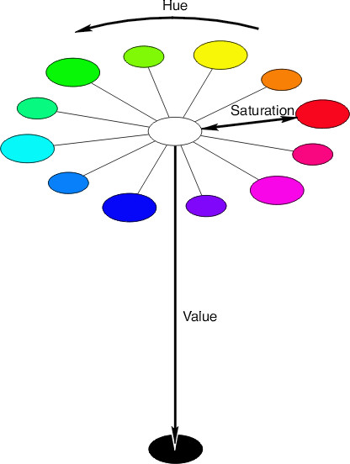

2. Complimentary color schemes are used to form different relationships of colors. The basic techniques are used to produce a wide range of color harmonies.
- Compliments (2 colors opposite each other): An example of a compliment would be red and green.
- Split compliments: An example of a split compliment would be red violet, blue violet and yellow. Violet would be the split color.
- Double split compliments: An example of a double split compliment would be red violet, blue violet, yellow green and yellow orange. The split colors would be violet and yellow.
- Analogous: An example of an analogous (colors adjacent to each other) would be yellow (parent) yellow green, green, yellow orange, and orange.

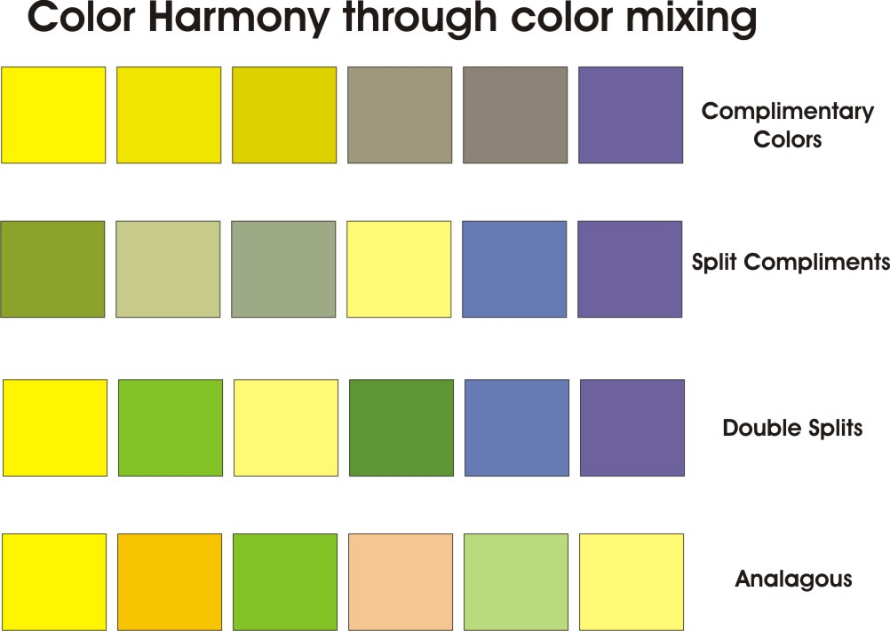
This example uses yellow and violet as compliments and yellow as the primary color.

3. Color output refers to how colored graphics and images are converted into different file and image formats for reproduction and use in different media.

D. Visual Communication is the method of providing information and persuasion via the use of images and words. Examples: brochures, newsletters, books, magazines, newspapers, web pages, multimedia and the multitude of products are used to keep us well informed as well as entertained.
UNIT D: Underlying Principles of Visualization

COMPETENCY: V104.
Apply basic principles of visualization.

OBJECTIVE: V104.03
Discuss vector and bitmap images.

Introduction: The purpose of this unit is to introduce students to vector and bitmap images.

A. Vector image
1. _______________________ (also called outline images) are images/objects defined with mathematical equations producing images with both magnitude (size) and direction (position). Type is considered to be vector because it is composed of lines and curves.
2. There are specific _______________ of vector over bitmap-based images.
a. Vector graphics are __________________ independent, which means they can be output to the highest quality at any scale.
b. Vector graphic images normally have much ______________ file sizes than raster-based bitmaps.
c. Changing or transforming the characteristics of a vector object does effect or ___________________the object.
d. Vector images are not limited to _____________________ shapes like bitmaps.
e. An image can be enlarged or reduced without affecting the ____________of the image.
f. There is no _____________________ unless it is placed behind the image as a layer.
g. Vector images have the appearance of artistic form such as ____________________.
h. Vector images can be easily converted to __________________images.
i. __________________________ are easily defined and will always be smooth and retain their continuity.
3. There are certain __________________ of vector images when compared to bitmap images.
a. The main disadvantage is they are not suited to ____________ realistic renderings.
b. Vector images are usually filled with _____________ or gradient colors but lack in depth and appearance in the values and colors of a true continuous tone image.
4. Vector images are drawn with basic line tools available in most graphic software programs.
a. The freehand tool is used to produce ______________ lines.
b. The pen tool is used to draw controlled curves called ______________ curves.
5. There are different classifications of vector images.
a. Simple line art is a 1 bit graphic image with large areas of _____________________.
b. ____________ line art is made up or many curves with linear contrast but still maintains the quality of a black and white image.
c. High detail line art is composed of curves and stippled __________ (simulates different styles of etching) to form values.
d. Colored _____________ images are composed of lines, solid colors, blended or gradient colors to simulate tonal changes and are produced using different color methods (opaque or transparent).
6. A common rule for vector images is to save the image in its native format in the software program being used first, and then ___________ the image into other desired formats.
a. The native format for Corel Draw is __________.
b. The native format for Illustrator is ______________.
c. The native format for Photoshop is PSD and Corel Paint is ______________.
B. Bitmap image
1. Bitmap images (also called ______________ images) are made from a grid filled with __________________ (picture element), which appear as rectangles. All the pixels, when combined for visual images, are called continuous tone images (contones). Bitmap images are resolution dependent, and this must be taken into consideration when producing images of different size and quality.
2. There are specific ____________associated to bitmap images.
a. ______________ is the density of the pixel grid. It is the number of pixels in an image and is referred to as dpi or dots per inch. Resolution is based on the number of pixels in an image, which is determined, by its width, height and depth.
Example: Image size = width in pixels x height in pixels

Image size = 4 pixels wide x 4 pixels high
Image size = _______________ pixels

b. A pixel is the ______________ display element that makes up the images seen on televisions and computer monitors.
3. There are some significant ___________________ for using bitmap images.
a. Bitmap images are ______________ converted to different formats.
b. Bitmap images are easier to_____________into different software applications.
c. Bitmap images produce a ________________ of continuous tone images.
d. Bitmap images are better suited for most high quality renderings and ___________ graphics.
4. There are disadvantages to using ____________- images.
a. Bitmap images produce ____________ files sizes.
b. Bitmap images have imposed ______________ in regards to alterations and modifications such as scale, image distortion, and format conversion.
c. There is a common appearance of blocked or ___________ edges and blurriness in the image, which must be compensated for with sharpness filters.
d. Substantial memory is required to work with ___________images.
e. When bitmap images are enlarged, jagged, stair-stepped edges called ______________ appear. ___________________ is available in some programs to help smooth jagged edges.



5. There are basic types of ____________ images used in a variety of mediums and formats.
a. Black and white images called line art are simple ___________images.
b. ________________ images contain various shades of gray as well as black and white.
c. Full color images use color information that can be described using a number of color spaces such as RGB, CMYK or ____________ colors.
6. Color Depth (bit depth)
a. A ___________ (binary digit) is the smallest unit of information used in a computer. The signal can be on or off, 1 or 0.
b. ________________ refers to the number of “colors” available and/or the amount of computer memory that will be required to store pixel values of an image.
c. Customary color depth settings:
Color settings | Numbers of colors | Examples
1 bit (black and white)
8 bit (grayscale)
8 bit color
24 bit color
d. The higher the _________ number, the more colors you have available, but the more computer memory required to store the image. _____________ should be considered when saving, creating, and scanning an image.
7. Image resolution
a. _____________ are picture elements or the dots on the monitor. Your monitor is set to a certain number of pixels and the pixels are a fixed size.
b. The number of pixels available on your monitor can be _________________.
c. Multiply the number of pixels across by the number of pixels up and down to find the total number on your screen. The ______________ that you have, the greater the memory needed to handle the display.
d. Image resolution is measured in ______________ (dpi) for printing and pixels per inch (_____________) for monitor displays.
e. The pixels per inch of a screen image translate directly into dots per inch on a ______________. A 72-ppi image that would look fine on a monitor would look fuzzy when printed at 72 dpi.
f. It is important to scan images to match the proposed __________. For example, an image that is to be printed should be scanned at a minimum of 300 dpi. The image should be scanned at a lower rate if it is going to be displayed on a ____________.
g. ______________ refers to image quality and sharpness. The higher the resolution, the larger the file size, but the clearer the image.
h. Images displayed on a monitor may not _____________ with printed output size. Usually the printed image will be smaller than the screen image because of the higher printing resolution.
i. Web images are typically around ________ppi. Printed images are generally _____ dpi or greater. Monitor images are approximately 70-100 ppi.
UNIT D: Underlying Principles of Visualization

COMPETENCY: V104.
Apply basic principles of visualization.

OBJECTIVE: V104.04
Identify effective 2D presentation techniques.

Introduction: The purpose of this unit is to familiarize students with proper 2D presentation techniques.

A. Elements used to produce visual aids
1. ______________ are pictorial elements such as line drawings, photographs, or continuous tone images.
2. Words are the arrangement and display of ___________ in various formats. Words are usually set as display or body type.
3. The basic _____________ shapes are circles, rectangles, triangles, or irregular 2D shapes.
4. _________ is simply referred to a hue and varies from one source to the next.
B. Planning and composition of presentations
1. ___________ are based on the audience and goal of the presentation.
2. ______________ is referred to as the attention given to any particular element that stands out in the presentation and is commonly known as or associated to the main idea.
3. ___________ in any presentation will either be formal or informal in arrangement.
4. _____________ refers to how heavy the elements used in the presentation appear with respect to the design characteristics.
5. Placement is the overlapping, closeness, or division that forms the ________________ (closeness) of the elements in the presentation.
C. Basic techniques for developing effective presentations
1. Basic methods of visual presentations:
a. Show how a finished visualization is used (_________________).
b. Show it in a natural or artificial environment (______________).
c. Show the final product by itself emphasizing its physical characteristics such as shape, texture, features, or color (_______________).
2. Conceptual techniques refer to how the presentation is formatted or arranged using the elements in different methods. There are several types used in layout and design:
- ________________ are the most popular format styles and are used when images dominate the largest proportions of the layout.
- __________________ is used when an enlarged typeface is the most important element in the layout.
- ____________ is used when the information or copy is the most important element in the layout.
- ________________, named after the artist Piet Mondrian, layouts are produced by dividing the space into rectangles of different scale and proportion. All of the text, headings, and images are placed in the rectangles.
- ______________ (circus layout) is used when a variety of elements are needed in the layout.
- __________ or Cartoon format uses panels of equal size and many times are used to tell a sequential story.
- _____________ has the text wrapped around an open image, which usually does not have a background.

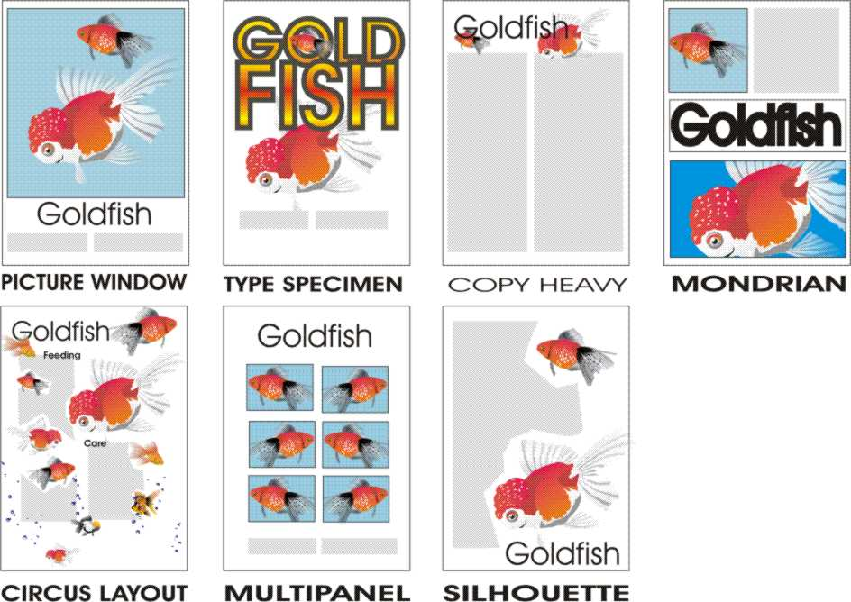
UNIT D: Underlying Principles of Visualization

COMPETENCY: V104.
Apply basic principles of visualization.

OBJECTIVE: V104.05

Describe 2D software applications and their basic functions.

Introduction: The purpose of this unit is to introduce students to the basic icons and concepts used in most scientific visualization software.

- Students should be able to identify basic 2D package tools and their functions.
1. Select tool -- allows you to select an object or selection.
2. Knife tool -- allows you to cut a selected object into two sections.
3. Magnify or zoom tool -- allows you to zoom in on an object so you can see the detail of the object.
4. Text tool -- allows you to add text to the design.
5. Fill tool -- allows you to fill a closed object with a fill. The fill may consist of a color, pattern, bitmap, or other acceptable fill.
6. Pan tool -- allows you to move the page around to view different parts of the layout. The object does not move.
7. Eyedropper tool -- allows you to copy color or fill attributes from a selected object for further use.
8. Gradient Tool -- allows you to blend from one color to another. Linear gradients blend from one side to another while radial gradients blend one color around another.
9. Blend tool -- allows you to blend from one object to another with the number of steps chosen by the designer.
10. Crop tool -- allows you to select a specific area of an image and remove the unwanted parts of the image.

- Students should identify the following 2D drawing techniques:

  - Bezier curves
  - Closed and open splines
  - Control points
  - Layering techniques
  - Welding and grouping
  - Contour effects
  - Working with a desktop
  - Grids and snaps
  - Brushes and brush effects
10. Line thickness
    - Rotation
    - Transparency techniques
    - Printing technique

- Students will be able to create a presentation using PowerPoint software.

  - Create slides.
  - Use backgrounds and master slides.
  - Insert images and movies from a file into slides.
  - Include slide transitions.
  - Navigate within slide views.
  - Use the drawing tool bar effectively.
  - Set up the PowerPoint show including timing for a group presentation.
9. Know your audience

D. Students will use layout concepts in creating PowerPoint slides.
Use a common background on each slide. Be careful with pictures in backgrounds.
Use the 6,6,6 rule. For example, no more than 6 lines, 6 bullets, or 6 words in a sentence.
No more than 2 images per page.
Use white space properly.
Follow the SAFE design methods.
Follow the principles and elements of design.
Use appropriate text size for slide

UNIT D: UNDERLYING PRINCIPLES OF VISUALIZATION

COMPETENCY: V104.
Apply basic principles of visualization.

OBJECTIVE: V104.06
Demonstrate effective presentation techniques using appropriate design fundamentals.

Introduction: The purpose of this unit to help students demonstrate their understanding of how design principles are applied to a design problem. Students will create a presentation in the form of a brochure.
Requirements:
- Students will produce a flyer or brochure that will be used in Biology and other science programs in their high schools. Each student must choose a different topic.
- The flyer will provide information about an organism. Research the organism. Include parts of the organism, habitat, feeding habits, special adaptations, and role in the environment. Examples of organisms might include protists, plants, animals, fungi, or bacteria. Students may choose from a random list.
- The student will create at least two original images of the organism that are produced using 2D software. No ClipArt is allowed.
- One image will be the dominant element in the layout and it will include labels and tags.
- Students will sketch the layout of the brochure or flyer. The typefaces (font) selected should compliment the theme of the flyer.
- The images must be sized to fit the space provided on the chosen layout. (See section 4.04)
- The color theme should enhance the realism of the organism. The layout must follow the principles and elements of design and the SAFE design method. (See Section 4.01 and 5.02)
- The final layout should include a mockup of a logo to be used as an identity mark for the student.
Assessment: The flyer will be evaluated on the following criteria:

Two original images 20 points
Flyer Layout 20 points
Use of design elements 20 points
Logo 10 points
Scientific accuracy 30 points
TOTAL 100 points
Rubric:

Two original images
Both images are not to scale, not of different views, or not scientifically correct. | One image is not to scale, or not of different views, or not scientifically correct. | Both images are to scale, are of different views, and are scientifically correct. | Total  Points
0- 10 points | 11- 19 points | 20 points

Flyer layout
A layout is chosen for the flyer. The layout does not have a picture as the point of focus and there is not a correct position of copy, heading, white space and/or images. There is not a sketch. | The appropriate layout is chosen for the flyer. The layout does not have a picture as the point of focus OR there is not a correct position of copy, heading, white space and/or images. There is a sketch. | The appropriate layout is chosen for the flyer. The layout has a picture as the point of focus. There is the correct position of copy, heading, white space and images. There is a sketch. | Total  Points
0- 10 points | 11- 19 points | 20 points

Use of design elements
The color harmonies are incorrect. The typefaces conflict with the flyer design and theme. More than two typefaces are used. The design is cluttered and white space is not used effectively. | The color harmonies are incorrect. The typefaces conflict somewhat with the flyer design and theme. More than two typefaces are used. The design is acceptable and white space is used somewhat effectively. | The uses of color harmonies are correct. The typefaces compliment the flyer design and theme. One to two typefaces are used. The design is clean and white space is used effectively. | Total  Points
0- 20 points | 21- 36 points | 20 points

Logo
The logo is not present. | The logo is present, not placed correctly on the flyer (small and in a corner) or is not appropriate for the student. | The logo is present, placed correctly on the flyer (small and in a corner) and is appropriate for the student. | Total  Points
0- 3 points | 4-7 points | 10 points

Rubric continued

Scientific accuracy
The flyer does not contain correct scientific information on 3 or more items including parts of the organism, habitat, feeding habits, special adaptations, and role in the environment. | The flyer does not contain correct scientific information on two or less items including parts of the organism, habitat, feeding habits, special adaptations, and role in the environment. | The flyer contains correct scientific information on the organism including parts of the organism, habitat, feeding habits, special adaptations, and role in the environment. | Total  Points
0- 18 points | 19-29 points | 30 points

