GO

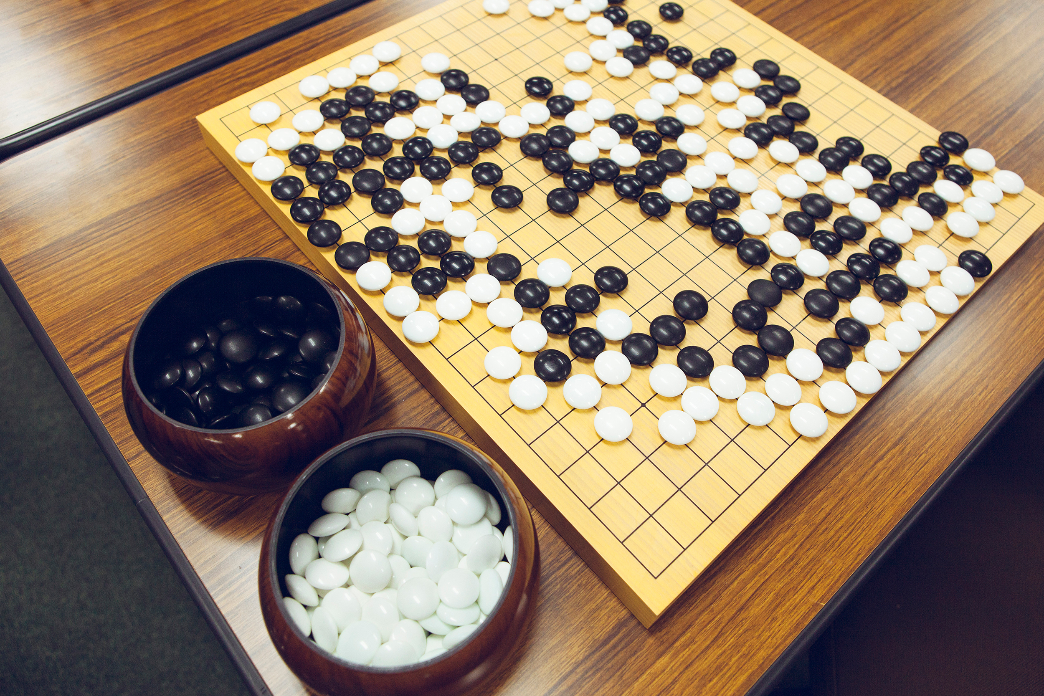

Some say that the board, with ten points out from the center in all directions, may have originally served as a forerunner to the abacus. Others think it may have been a fortune-telling device, with black and white stones representing yin and yang. A prominent legend holds that the sage-king Yao created the game to teach his rebellious son discipline.

By 400-300 B.C., Chinese scholars such as Confucius were writing about wei-chi (a Chinese name for the game) to illustrate correct thinking about filial piety and human nature. By the 1600's it had become one of the "Four Accomplishments" (along with calligraphy, painting, and playing the lute) that must be mastered by the Chinese gentleman. This kind of sanctified thinking about the game has inspired people to play for millennia.

Originated in Ancient China, 2,500-40,000 years ago. Well people, it came to be in ancient china!

Two players are involved in this game, how interesting. The game looks like a simple squared board with smaller squares inside. The game pieces look like skittles butt bigger and black and white.

## Yes rules do exist for this game!

In general black goes first. Take turns placing one stone. Surround territory. Depending on where you are they vary, so there it is very simple but uses a lot of brain power and strategy.

Well how long does it take? Well there isn’t really a time limit but let’s just say till you get defeated, win, or tie.

Igo Baduk/Paduk Weiqi ("way-chee") are what this game is called in Japanese.

Chess and backgammon are games that are similar to go. I personally like strategy games, because I think the more you use your brain the smarter and better you’ll know how to manage certain situations you get in. Soi comes in handy, what do you know!

## Done by:

Melissa Coria-Abad

By: Melissa Coria-Abad