History and Impact of SciVis

- What was the first evidence of visual communication left behind by man?
Cave drawings, and early language, paintings and hieroglyphs.
- How did modern languages evolve?
Different people traveling brought people from different cultures together.
- Define PERSPECTIVE drawings.
Observing things around you and make or produce realistic images.
- What is a MAP?
A flat representation of a 3D space.
- What features do Maps use to show points, lines, or areas?
Size, shape, value, texture, pattern, color, and orientation.
- What do the following Maps portray?

  - Road- roadways and physical boundaries.

  - Topographic- contour lines that show elevation.

  - Aeronautical- have information about flight paths.

  - Concept- show locations of weather patterns.

  - Spider- is organized by placing the central theme or unifying factor in the center of the map. Outwardly radiating sub-themes surrounding the center of the map.

  - Hierarchy- concept map presents information in a descending order of importance. The most important information is placed on the top.

  - Flow Chart- concept map organizes information in a linear format.

  - Gene- shows locations of specific genes in DNA

  - Floor Plan- shows rooms in a building.

- In a Blank Powerpoint document and label an example of each of the following maps. Provide an explanation of each map and what they are used for.

Road map
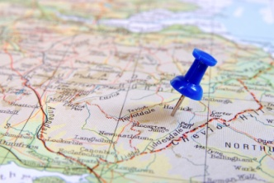
These maps are used for directing people if they get lost.

Topographic Map
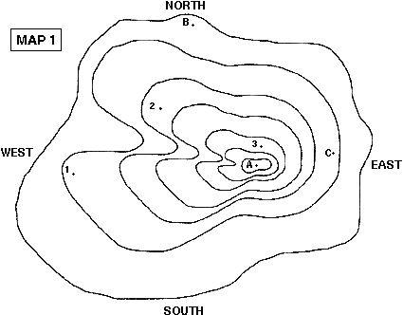
This map is used to in many types of geographic planning, or architecture. They are also used in mining, and recreational activities such as hiking.

Aeronautical Map
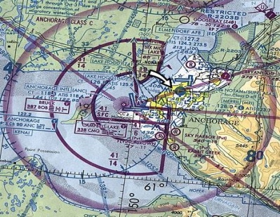
This is used to provide important information to the pilot and tell him where to go in case of an emergency.

Weather Map
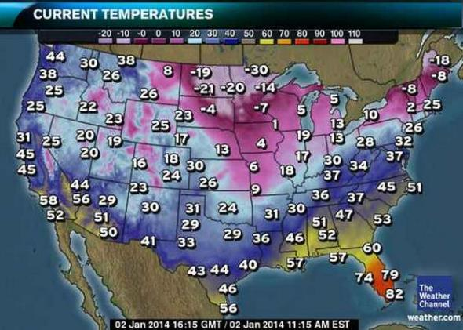
This map is used to research and for weather forecasting purposes.

Gene Map
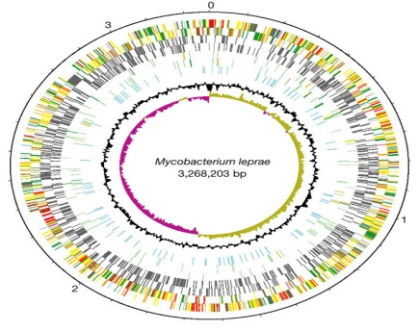
To find the single gene responsible for relatively rare inherited disorders.

Concept Map
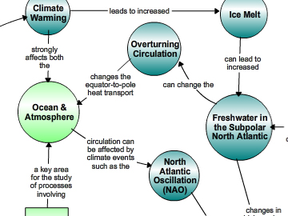
Used as a learning and teaching technique visually illustrates the relationships between concepts and ideas.

Floor Plan
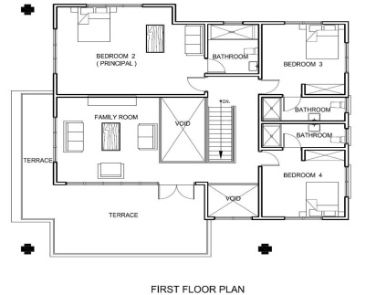
Used in general to describe any drawing showing the physical layout of objects.

